HANDS-ON EVIDENCE WRITEUP 03 / 04

Ubuntu Snort: ICMP, HTTP, SSH Rules
  - Objective → test → observed result → SOC interpretation

Objective
Configure Snort as an IDS on Ubuntu enp0s8 and test first three local rules.

Method
Configured HOME_NET=192.168.56.0/24; monitored interface enp0s8; validated Snort configuration using -T; generated ICMP, HTTP and SSH traffic from Kali.

Evidence
Screenshots show ICMP alerts (SID 1000001), SSH (1000002), HTTP (1000003), and validation success.

SOC significance
Signature alerts can highlight reconnaissance and unexpected service exposure. Traffic from intentionally generated lab tests is benign; severity depends on context.
sudo snort -T -i enp0s8 -c /etc/snort/snort.conf
sudo snort -A console -q -c /etc/snort/snort.conf -i enp0s8
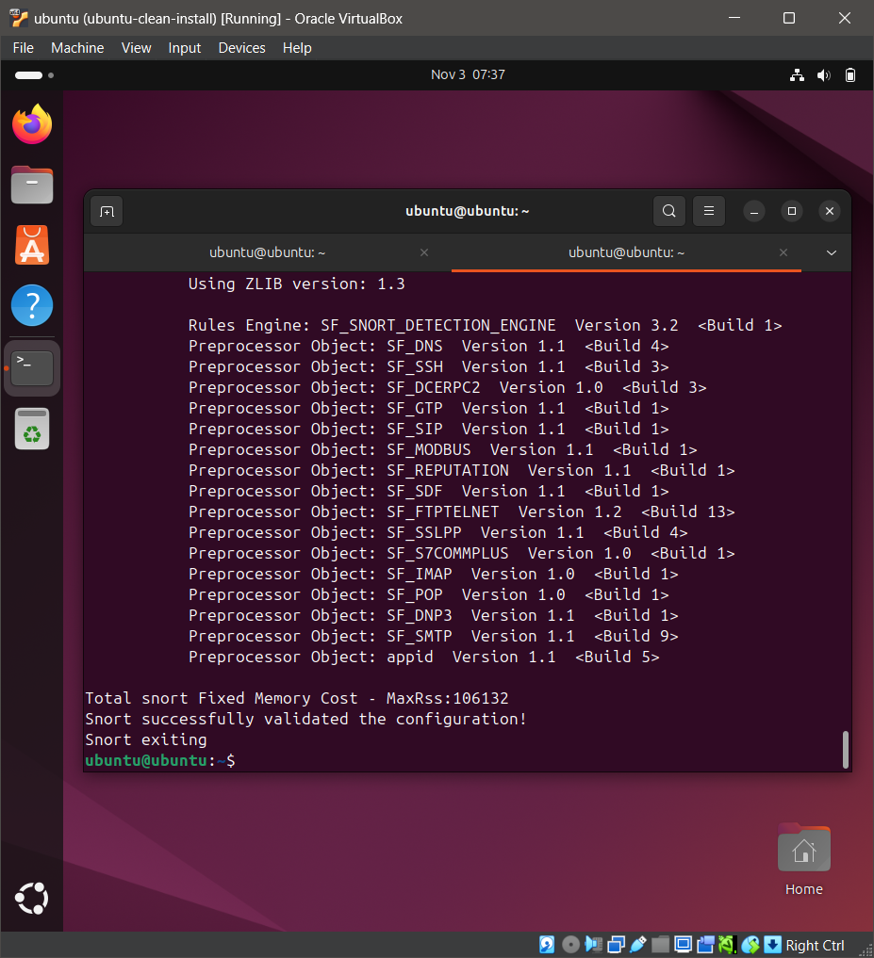
05 Snort Configuration Test
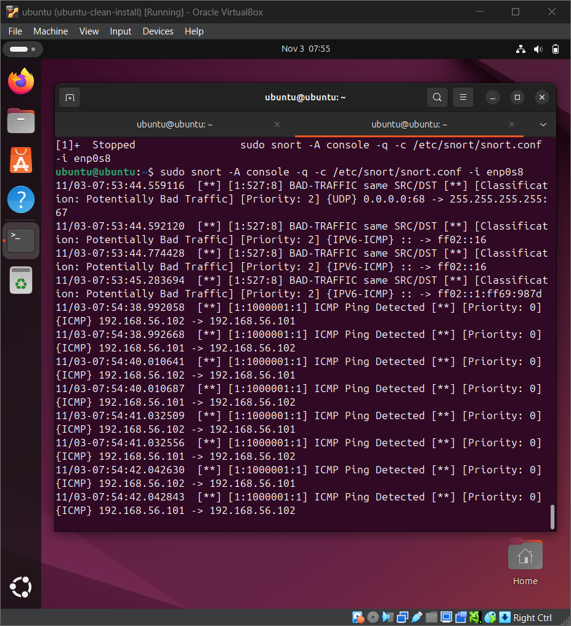
06 Snort ICMP Ping Alert
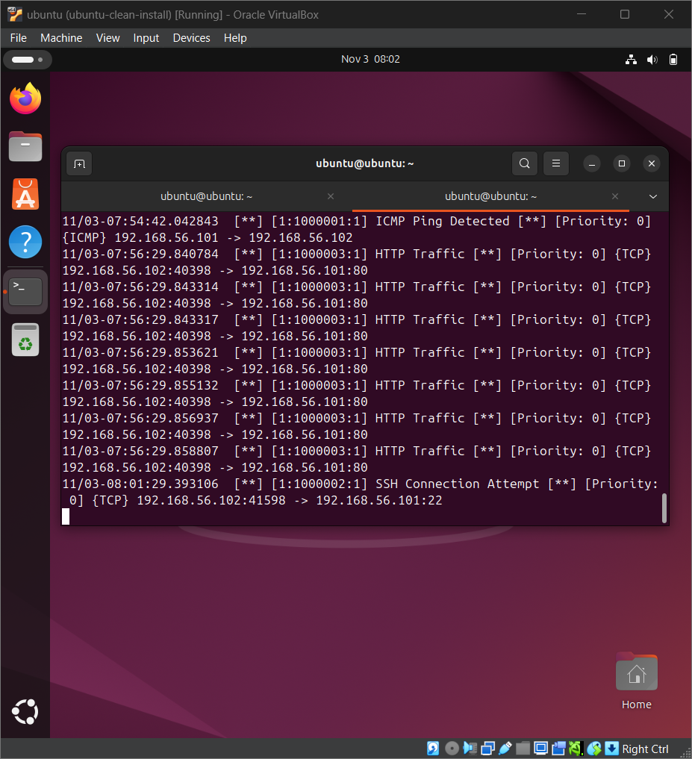
09 Snort SSH Connection Alert

